**Test Strategy for Player class**

There are three mutators In Player class. They accept parameters and set the value of different fields. There are some restrictions on these fields. Goals and finalGoals should be equal to or greater than zero. Player’s name can contain only alphabetical characters and at most one hyphen, ‘-‘, to accommodate names that may be hyphenated such as Zeta-Jones. There must be a minimum of two alphabetic characters in the name, it should be of a sensible maximum length, and it cannot begin or end with a hyphen. The two players in a team cannot have the same name.

However, the Player class is designed to be a server class, so the complicated validation for player’s name is implemented in the Team class, a client class. There are only some basic validations for goals and finalGoals in Player class.

**Test Plan:**

1. Create a Player object with the default constructor

2. Create a Player object with the non-default constructor

(a) with valid field values

(b) with invalid field values

3. Test all the get methods

4. Test all the set methods

(a) with valid arguments

(b) with invalid arguments

**Test 1 : Create an Employee object with the default constructor.**

|  |  |  |
| --- | --- | --- |
|  | Test Data | Expected Data |
| name | No input |  |
| goals | No input | 0 |

Actual Result:

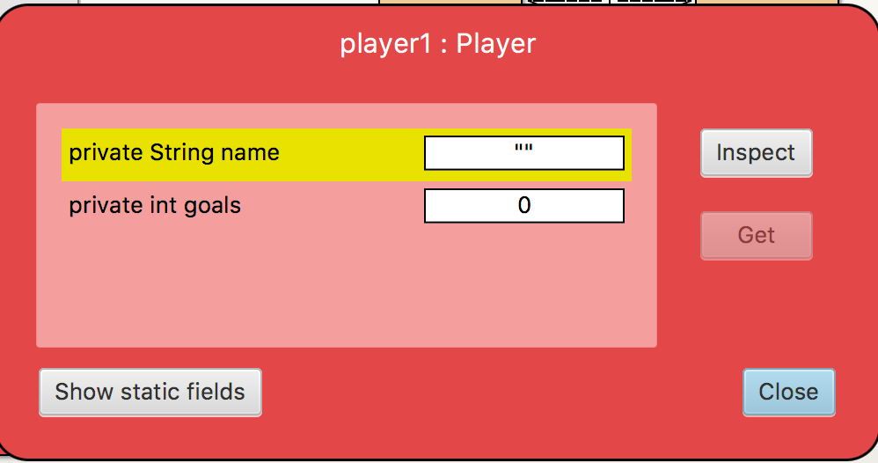

**Test 2 : Create an Employee object with the non-default constructor.**

1. with valid field values

|  |  |  |
| --- | --- | --- |
|  | Test Data | Expected Data |
| name | Ronaldo | Ronaldo |
| goals | 0 | 0 |

Actual Result:

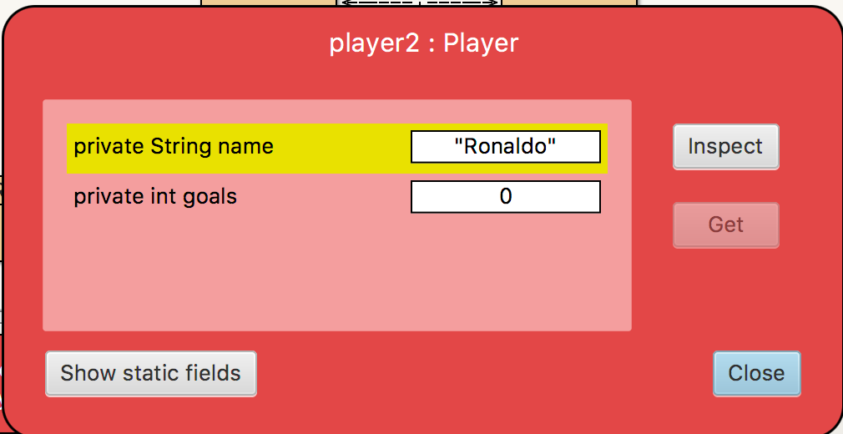

1. with invalid field values

|  |  |  |
| --- | --- | --- |
|  | Test Data | Expected Data |
| name | Ronaldo | Ronaldo |
| goals | -1 | 0 |

Actual Result:

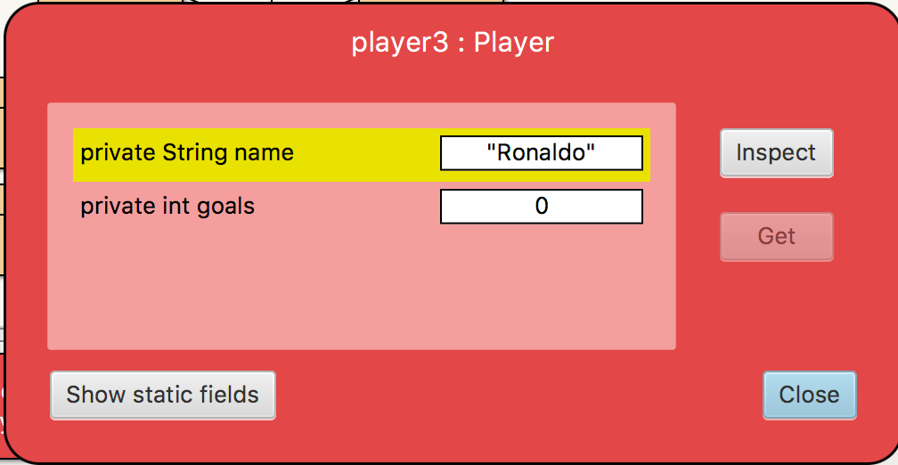

**Test 3 : Test all the get methods**

1. test the getName method

Expected Data: Ronaldo

Actual Result:

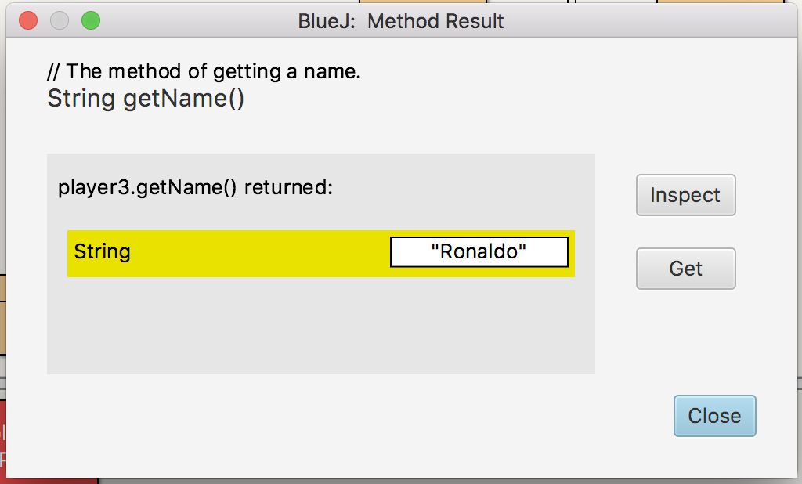

1. test the getGoals method

Expected Data: 0

Actual Result:

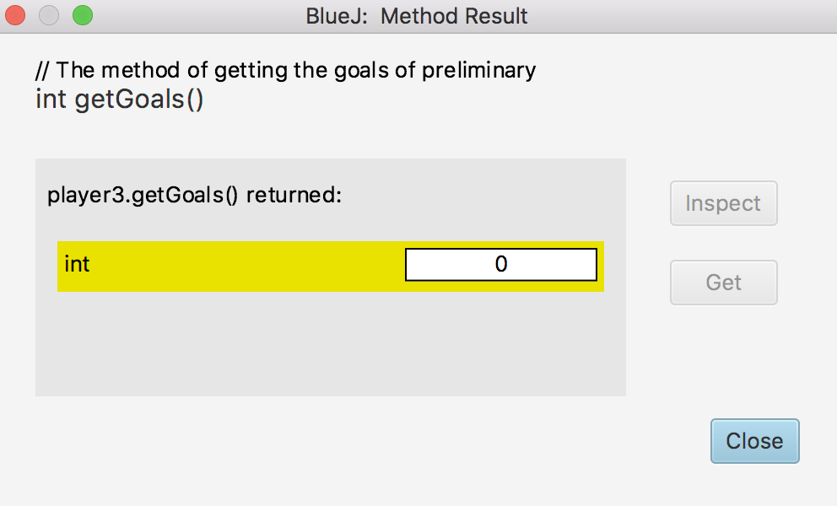

**Test 4 : Test all the set methods**

1. test the setName method

Test Data: Messi

Expected Data: name-Messi, goals- 0

Actual Result:

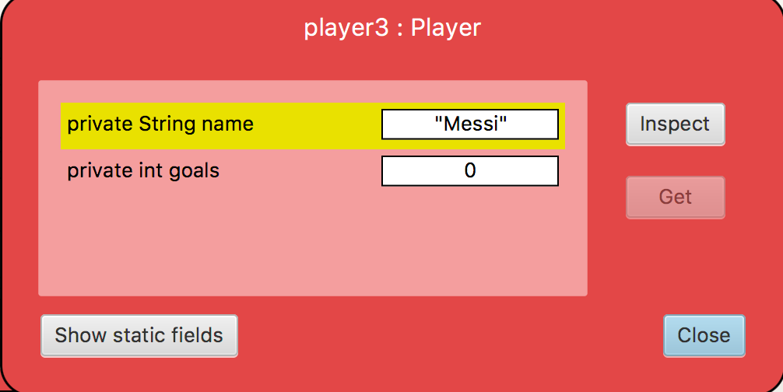

1. test the setGoals method with valid argument

Test Data: 100

Expected Data: name Messi, goals 100

Actual Result:

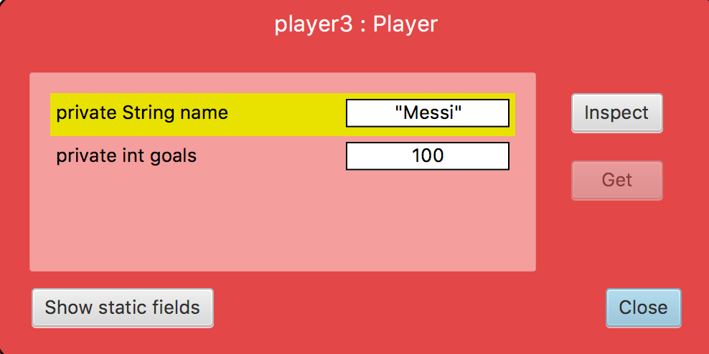

1. test the setGoals method with invalid argument

Test Data: -1

Expected Data: name Messi, goals 100

Actual Result:



